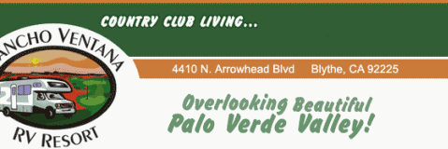

Lot Sales Form
Lot Number
Contact Name
Email
Phone Number
Type of Lot
(Bare Lot, Trailer, Park Model)
Property Description
(Include Year, Make, Size)
Price
Website Link (if available)

Fee: $5.00 per month or $50.00 per year (non refundable)

Number of Months: _______________

Form of Payment: (Circle) Cash Cheque

Fee: ($5/month/$50/year) Total $ ___________

Date Submitted: ___________________________________________

